TNS FOUNDATION C2TC TECHNICAL TRAINING

**ASSIGNMENT-1**

**NAME**: R. KISHAN KUMAR

**COLLEGE NAME :** SMIT

**YEAR :**FINAL YEAR

1. **Write a java program - create a class name as animal, create 3 objects, create 3 attributes, and create 3 methods?**

PROGRAM:

class Animal {

public void eat()

{

System.out.println("eat method");

}

public void sleep()

{

System.out.println("sleep method");

}

}

class Bird extends Animal{

@Override

public void eat() {

super.eat();

System.out.println("overide eat");

}

@Override

public void sleep() {

super.sleep();

System.out.println("override sleep");

}

public void fly()

{

System.out.println("in fly method");

}

}

class Animals{

public static void main(String[] args) {

Animal a =new Animal();

Bird b = new Bird();

a.eat();

a.sleep();

b.eat();

b.sleep();

b.fly();

}

}

OUTPUT:

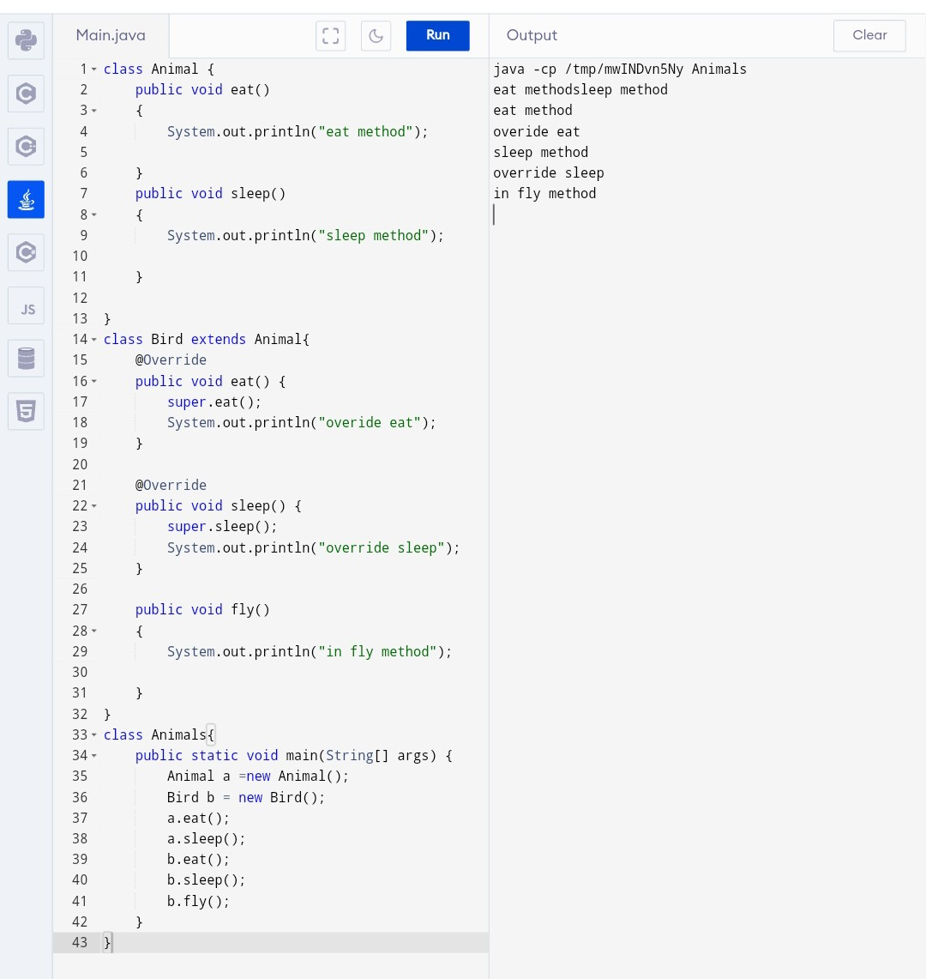

1. **Write a java program - using for loop/condition to print the helloworld program, if it is a input is less than 10 then print hello world for many times**

PROGRAM:

public class HelloWorld {

public static void main(String[] args) {

for (int i = 0; i < 10; i++) {

System.out.println("Hello World");

}

}

}

OUTPUT:

